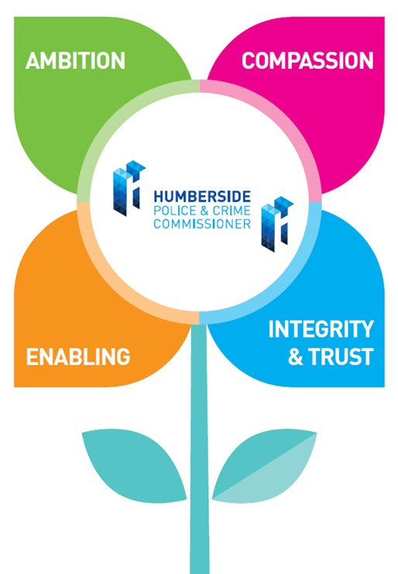
Your Job Title: Evaluation and Insight Officer

This role is hosted by the OPCC on behalf of the Humber Violence Prevention Partnership (VPP), a Home Office-funded Violence Reduction Unit (VRU).

Your Salary and Rewards: This is a part-time (0.6 FTE), fixed term role with a contract end date of 31st of March 2027.

This is a Band D role, meaning your salary will be 20,604 per year (0.6 FTE, equivalent to 34,340 full-time)

Your contribution to the OPCC will be: To plan and implement a range of evaluations. This will include carrying out fieldwork, collating data, analysing results and producing high-quality well-evidenced reports.

Your area of work will cover the following:

The Evaluation Officer will play a key role in supporting the VPP to understand the impact of its work in reducing serious violence and improving community safety.

You will design, deliver, and support robust monitoring and evaluation activities across a range of interventions, ensuring that evidence informs decision-making, funding, and future strategy.

Your business as usual will include:

- Working with our interventions to help design and implement logic models and theories of change.
- Conducting qualitative and quantitative research which may include surveys, interviews, focus groups and case studies.
- Analysing monitoring data to measure intervention effectiveness against eligibility criteria.
- Producing evidence-led evaluation reports, that translate data into actionable insight.
- Presenting findings to non-technical audiences, transforming technical language for non-subject experts.
- Acting as a “system joiner-upper”, working collaboratively across criminal justice, health, local authorities, voluntary sector and our intervention providers.
- Championing evidence-based approaches, with a focus on local needs, “what works” and effective measurement and evaluation of outcomes.
- Staying up to date with best practice in violence prevention and evaluation methodologies.
- Ensuring that all products are fully compliant with information compliance and data protection regulations and protocols.

Decision Making | Leadership | Managing Risk
Has limited decision making requirements.  Would usually follow specific process as directed by line manager. | Will engage with some partnership working with internal and external stakeholders. | Will identify risks and make suggestions around how to mitigate them.

How You Fit:

You will be managed by our Data and Analysis Manager who will provide you with both challenge and support in your role with us. (Please see the diagram below of our structure)

Our Values:

We thought carefully about our values, and they are owned by everyone.

They are used as the foundation for all we do and a fundamental part of how we undertake recruitment and selection.

There is an expectation that collectively we will strive to achieve great things, enjoy our work, make one another proud, and work with the public in mind always.

AMBITION | You will demonstrate a commitment to the highest standards, best outcomes and continuous improvement for all areas of your work and the work of the OPCC and Humber VPP.
COMPASSION | You will be a people person and understanding of the vulnerabilities of those we are here to support and the needs of others. You will support and provide help to your team and consider the public in all you do.
ENABLING | You will seek out opportunities to connect pieces of work, people, and partners where you see the potential for working together better. You will embrace collaboration where it is in the interests of the public.
INTEGRITY & TRUST | You will always conduct yourself in a way that allows your team, partners, and the public to trust you and demonstrate that you trust them. You will challenge where you see potential breaches in trust.

You Will Have:

- A natural fit with our values and your approach to your work will clearly reflect them
- Degree (or equivalent experience) in a relevant field (e.g. social research, criminology, public health, statistics)
- Experience in monitoring and evaluation, research, or data analysis
- Strong analytical skills and experience working with quantitative and qualitative data
- Ability to produce high-quality reports and communicate findings clearly
- Proficiency in data analysis tools (e.g., Excel; Power BI, Tableau desirable)
- Understanding of ethical considerations and data protection (e.g., GDPR)
- Excellent organisational skills and ability to manage multiple projects
- Ability to use own initiative and apply analytical thinking
- Ability to complete tasks accurately within pre-determined time scales
- Ability to collaborate effectively in cross-functional teams
- Flexibility to meet the demands of the role
- Willingness to learn and undertake a variety of tasks
- An enquiring mind and an interest in working with complexity and challenge
- A passion for our communities across Humberside

You may have:

- A masters degree in social research, criminology, public health, statistics or a related field
- Experience working in violence reduction, community safety, or public health
- Knowledge of evaluation frameworks (e.g., logic models, process evaluations)
- Experience working in multi-agency partnerships or public sector environments
- Familiarity with UK policy context relating to violence prevention
Our Organisation – Our People
