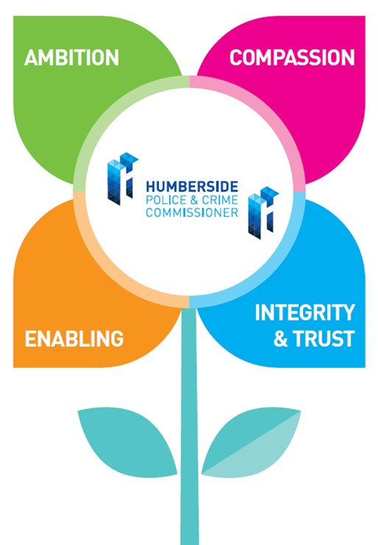
Your Job Title: Programme Support Officer

This role is hosted by the OPCC on behalf of the Humber Violence Prevention Partnership (VPP), a Home Office-funded Violence Reduction Unit.

Your Salary and Rewards: This is a Band F role

Your Contribution to the OPCC will be: Provide programme support to the Humber Violence Prevention Partnership.

Your business as usual will include:

- Supporting grant management, commissioning and project monitoring processes, such as onboarding providers, processing claims and recording information.
- Maintaining project/programme documentation, records and filing systems.
- Co-ordinating and obtaining updates to project/programme management information, including the VPP’s delivery plan.
- Supporting the VPP team in a range of business areas including purchasing, organising meetings and events, and arranging travel.
- Providing administrative support to the VPP’s Board and sub-groups, including collating reports and taking minutes.
- Communicating with delivery providers and partners to share and obtain information, answer routine enquiries and triage correspondence.
- Supporting the organisation and running of events, including liaising with suppliers and volunteers and registering guests.
- Performing such other duties as reasonably correspond to the general character of the post and are commensurate with its level of responsibility.

Decision Making | Leadership | Managing Risk
Has limited decision making requirements.  Would usually follow specific process as directed by line manager. | Will engage with some partnership working with internal and external stakeholders. | Will identify risks and make suggestions around how to mitigate them.

How you fit:
You will be managed by our Public Health Business Manager who will provide you with both challenge and support in your role with us. You will work closely with our Programme Coordinator, who will provide you with day-to-day supervision for most areas of your work. (Please see the diagram below of our structure)

Our Values:

We thought really carefully about our values, and they are owned by everyone.

They are used as the foundation for all we do and a fundamental part of how we undertake recruitment and selection.

There is an expectation that collectively we will strive to achieve great things, enjoy our work, make one another proud, and work with the public in mind at all times.

AMBITION | You will demonstrate a commitment to the highest standards, best outcomes and continuous improvement for all areas of your work and the work of the OPCC.
COMPASSION | You will be a people person and understanding of the needs of others and yourself. You will support and provide help to your team and consider the public in all you do.
ENABLING | You will seek out opportunities to connect pieces of work, people, partners where you see the potential of better working together. You will embrace collaboration where it is in the interests of the public.
INTEGRITY & TRUST | You will always conduct yourself in a way that allows your team, partners and the public to trust you and demonstrate that you trust them. You will challenge where you see potential breaches in trust.

You will have:

- Excellent literacy and numeracy, educated to A-Level standard or equivalent.
- Great attention to detail.
- Experience of working in an office environment.
- Experience of using computers to input and retrieve information.
- Confident user of Microsoft Office applications, and a willingness to learn new systems.
- Good interpersonal skills.
- Keyboard skills.
- Ability to collate information.
- Ability to understand and work with numerical information in spreadsheets.
- Ability to prioritise and manage own workload.
- Ability to use own initiative and apply common sense thinking.
- Ability to complete tasks accurately within pre-determined timescales.
- Flexibility to meet the demands of the post.
- Willingness to learn and undertake a variety of tasks.

You may have:

- BTEC or equivalent in a business or administration related subject.
- Experience of supporting the management of projects or programmes.
- Experience of supporting grant management, commissioning or procurement processes.
- Experience of taking notes/minutes.
- Knowledge of, or interest in, violence prevention, community safety, policing, public health or related areas of work.

Our Organisation – Our People

